1 задание

n = int(input())
print(n,'Вершины')
m = []
for i in range(n):
m.append(input().split())
print('Ввод окончен')

for i in range(n):
sum = 0
k = ''
for j in range(n):
if(m[i][j] == '1'):
sum = sum + 1
k = k + str(j+1) + " "
print("sum =", sum,",", i+1, ":", k)

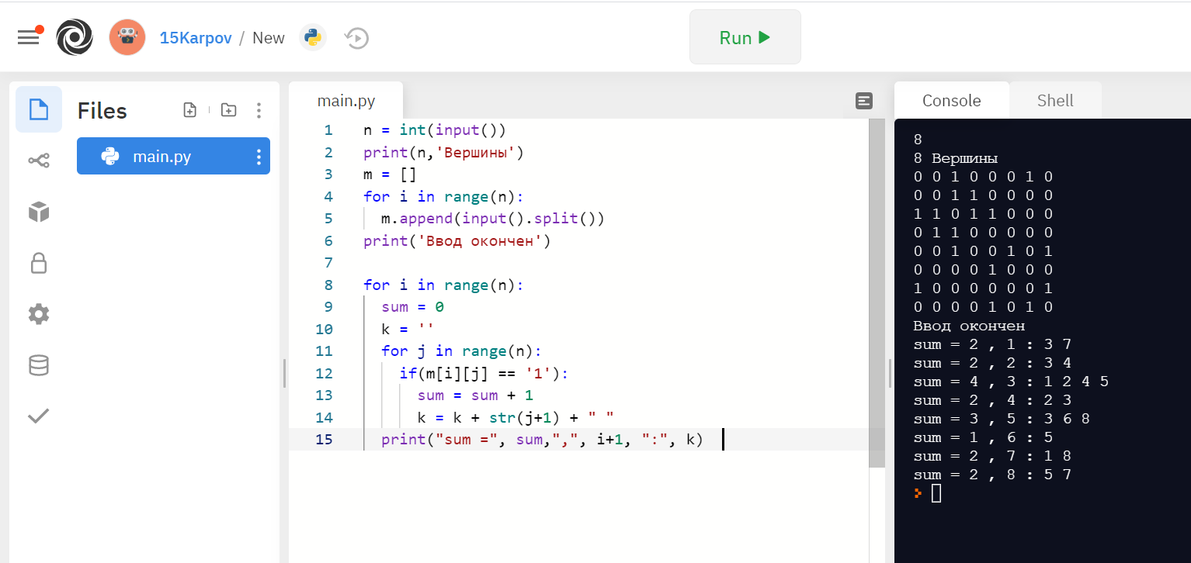

Задание 2
n = int(input())
m = int(input())
arr = []
for i in range (n):
arr.append([])
for i in range(m):
s = input().split()
first = int(s[0])-1
second = int(s[1])-1
arr[second].append(first+1)
arr[first].append(second+1)
for i in range(n):
k = str(sorted(arr[i]))
k= k.replace('[', '')
k= k.replace(']', '')
print(i+1, ":", k)

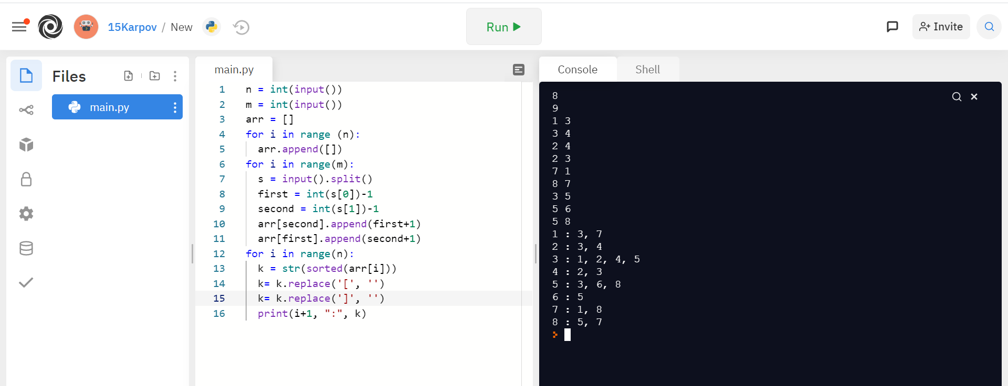

Задание 3
n = int(input("Введите количество вершин: "))
lst = []
pairs = []
print("Введите список смежности по типу '1:3,2' ")
for i in range(n):
s = input().split(":")
s[1] = s[1].split(',')
lst.append(s[1])

for i in range(n):
for j in range(len(lst[i])):
pairs.append([int(i+1),int(lst[i][j])])
print("Ввод окончен")
pairs2 = pairs.copy()
for i in range(len(pairs)):
for j in range(len(pairs)):
f1 = int(pairs[i][0])
f2 = int(pairs[j][0])
s1 = int(pairs[i][1])
s2 = int(pairs[j][1])
if(f1 == s2 and s1 == f2):
pairs2.remove(pairs[i])
pairs[i].reverse()
print("Список ребер:")
for i in range(len(pairs2)):
print(pairs2[i])

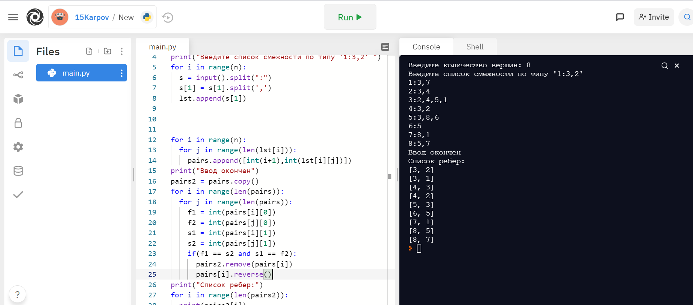

Задание 4
s1 = input().split()
n = int(s1[0]) # кол-во вершин
m = int(s1[1]) # кол-во ребер

arr = [] # список смежности
for i in range (n):
arr.append([])

for i in range(m):
s = input().split()
first = int(s[0])-1
second = int(s[1])-1
arr[second].append(first+1)
arr[first].append(second+1)

v = int(input()) # исходная точка

arr_smezh = [False for i in range(len(arr))]
output = []

def dfs(node):
arr_smezh[node-1] = True
output.append(node)
count = 0
for neighbor in arr[node-1]:
if arr_smezh[neighbor-1]:
count = count + 1
if not arr_smezh[neighbor-1]:
dfs(neighbor)
if count == len(arr[node-1]):
output.append(node-1)

dfs(v)
print("Список смежности:")
print(arr)
print("Количество ходов:")
print(len(output))
print("Список точек:")
print(output)

